QuickBooks UAT Sandbox Configuration and Access Guide
Nefi Lopez
2026-03-24

QuickBooks UAT Sandbox Configuration and Access Guide

Server Overview
This Sandbox Server serves as a UAT (User Acceptance Testing) environment. It features restricted internet access managed by SimpleWall (an application-level firewall).
Primary Objective: Only allow the AppFolio API so the synchronizer between AppFolio and QuickBooks Desktop can call the API without exposing the server to the public internet insecurely.

Virtual Machine (VirtualBox) Warning
The main linked virtual machine is QB-Isolated.
Please DO NOT DELETE QB-Isolated or QB-Isolated-PreQB.

Connection and Usage Workflow
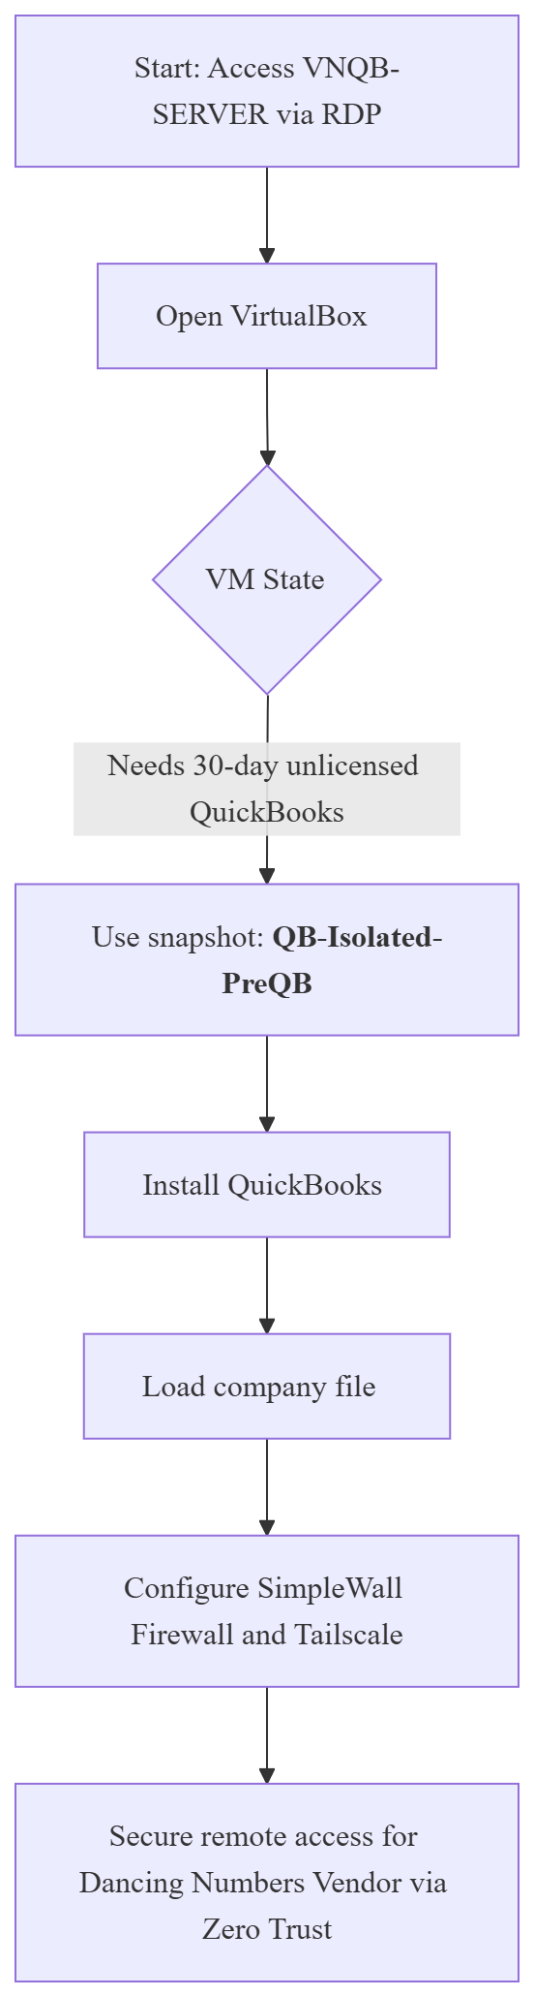

1. Accessing the Server and Virtual Instances
- Log into the host server.
- The server is located at the internal IP: 192.168.0.68 with the hostname VNQB-SERVER.
- Open VirtualBox.
- 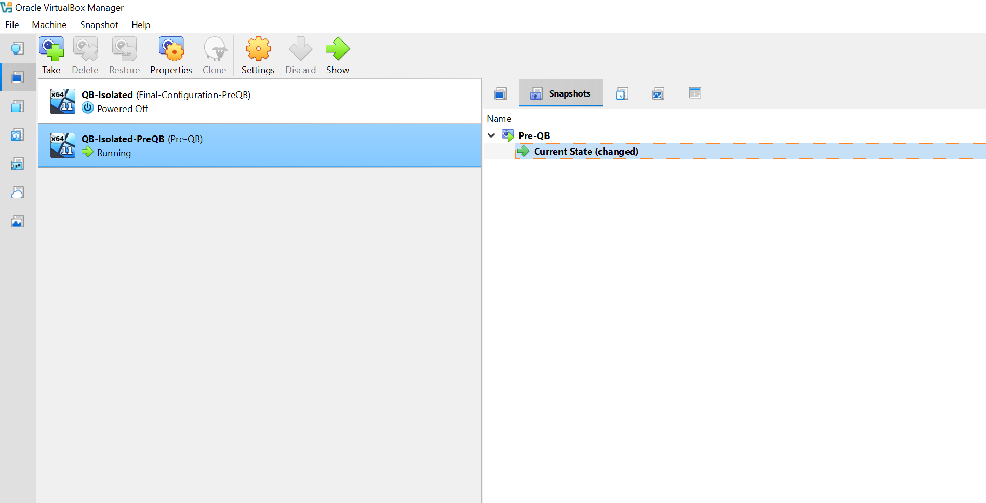
- Use the virtual machine with the QB-Isolated-PreQB state exclusively.
  - Configuration Note: QB-Isolated-PreQB is a state prior to QuickBooks installation. It uses an unlicensed Non-Profit edition of QB Desktop, valid only for 30 days for QA computing and testing purposes.
- Installation files are located on the host at: C:\Users\nefil\OneDrive\Documents\Casa-Familiar-Sandbox-File (includes the QB Installer).

- The image above shows the VM in the "Pre-QB" state. In that snapshot, all configurations are already set (Tailscale and Firewall), except for QuickBooks.
- Install QB and use the imported company file.
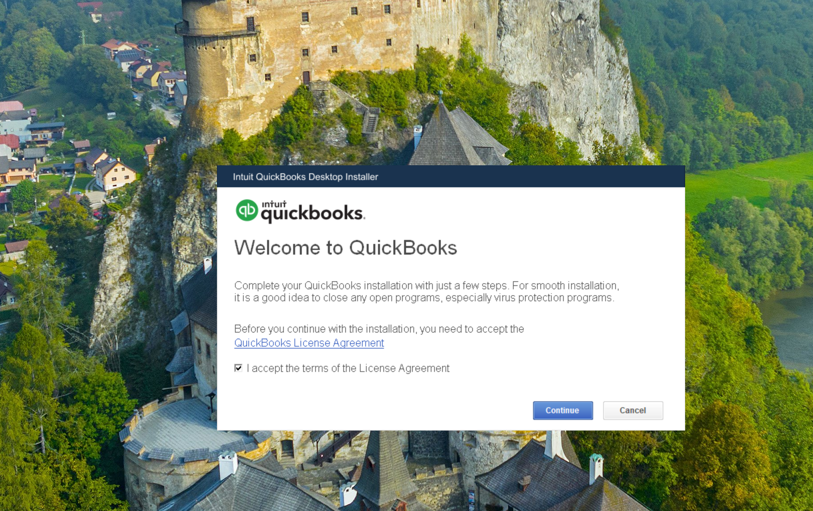

2. Credentials and Network (Zero Trust VPN)

QuickBooks Company File Account
- User: Admin
- Password: C@sa12345678

Tailscale Account
- User: nefilcf@gmail.com
- Password: CasaF@2026..

NOTE:
nefilcf@gmail.com is linked to the user nefil@casafamiliar.org for password recovery.

Local Virtual Machine Accounts
- Administrator:
  - User: admin
  - Password: CasaF@2026 (Local user)
- Dancing Numbers (IT Vendor):
  - User: dancing-numbers
  - Password: 12345678
  - Security Note: Internet access is blocked by default for this account.
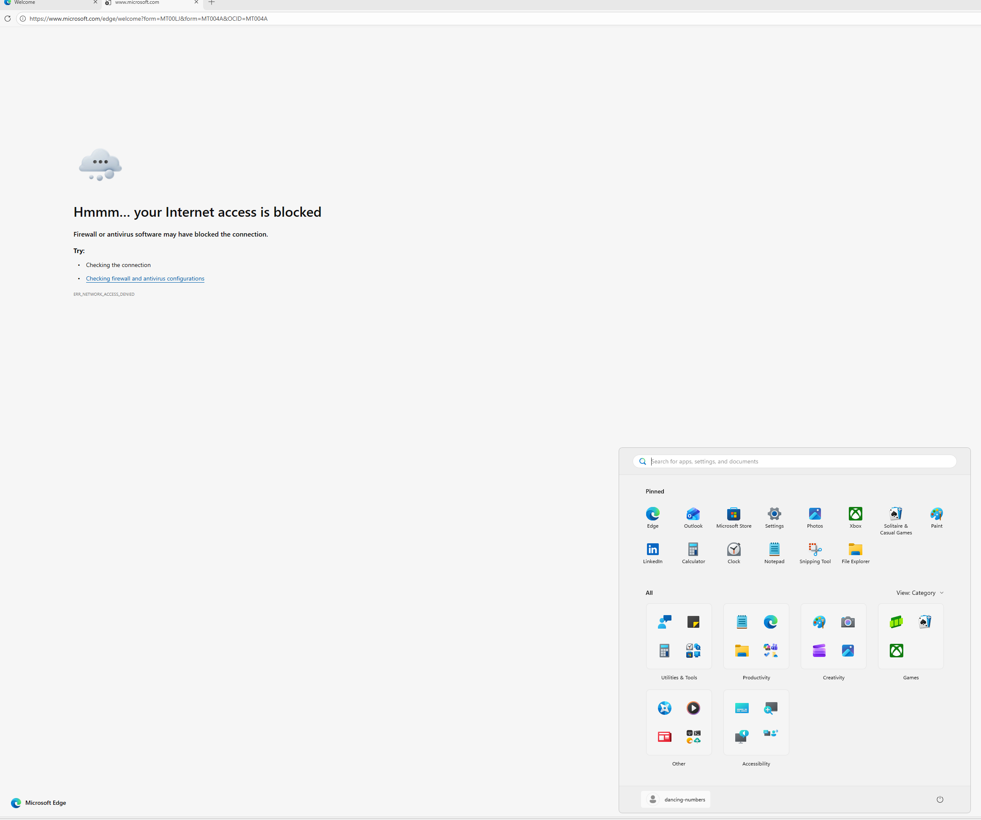

Tailscale VPN (Zero Trust)
Our vendor, Dancing Numbers, will be invited to use our VPN under a Zero Trust framework. This prevents exposing the QuickBooks database publicly.
What is Tailscale and Why Use It?
Tailscale is a zero-config mesh VPN built on WireGuard. We use it to create a Secure Intranet (Zero Trust Network) without opening external inbound ports on our main router or exposing the server to the public internet. This ensures the UAT server remains securely isolated while granting explicit, encrypted access only to authorized devices like our IT vendor.
Configuration Requirements for Tailscale:
- An active Tailscale Account (credentials provided above).
- The Tailscale application installed on both the UAT Server and the vendor's machine.
- Network authorization within the Casa Familiar Tailnet.
- Appropriate SimpleWall rules allowing tailscaled.exe and tailscaled-ipn.exe to communicate.
Setup Steps:
- Tailscale is the mesh VPN software configured in this UAT sandbox.
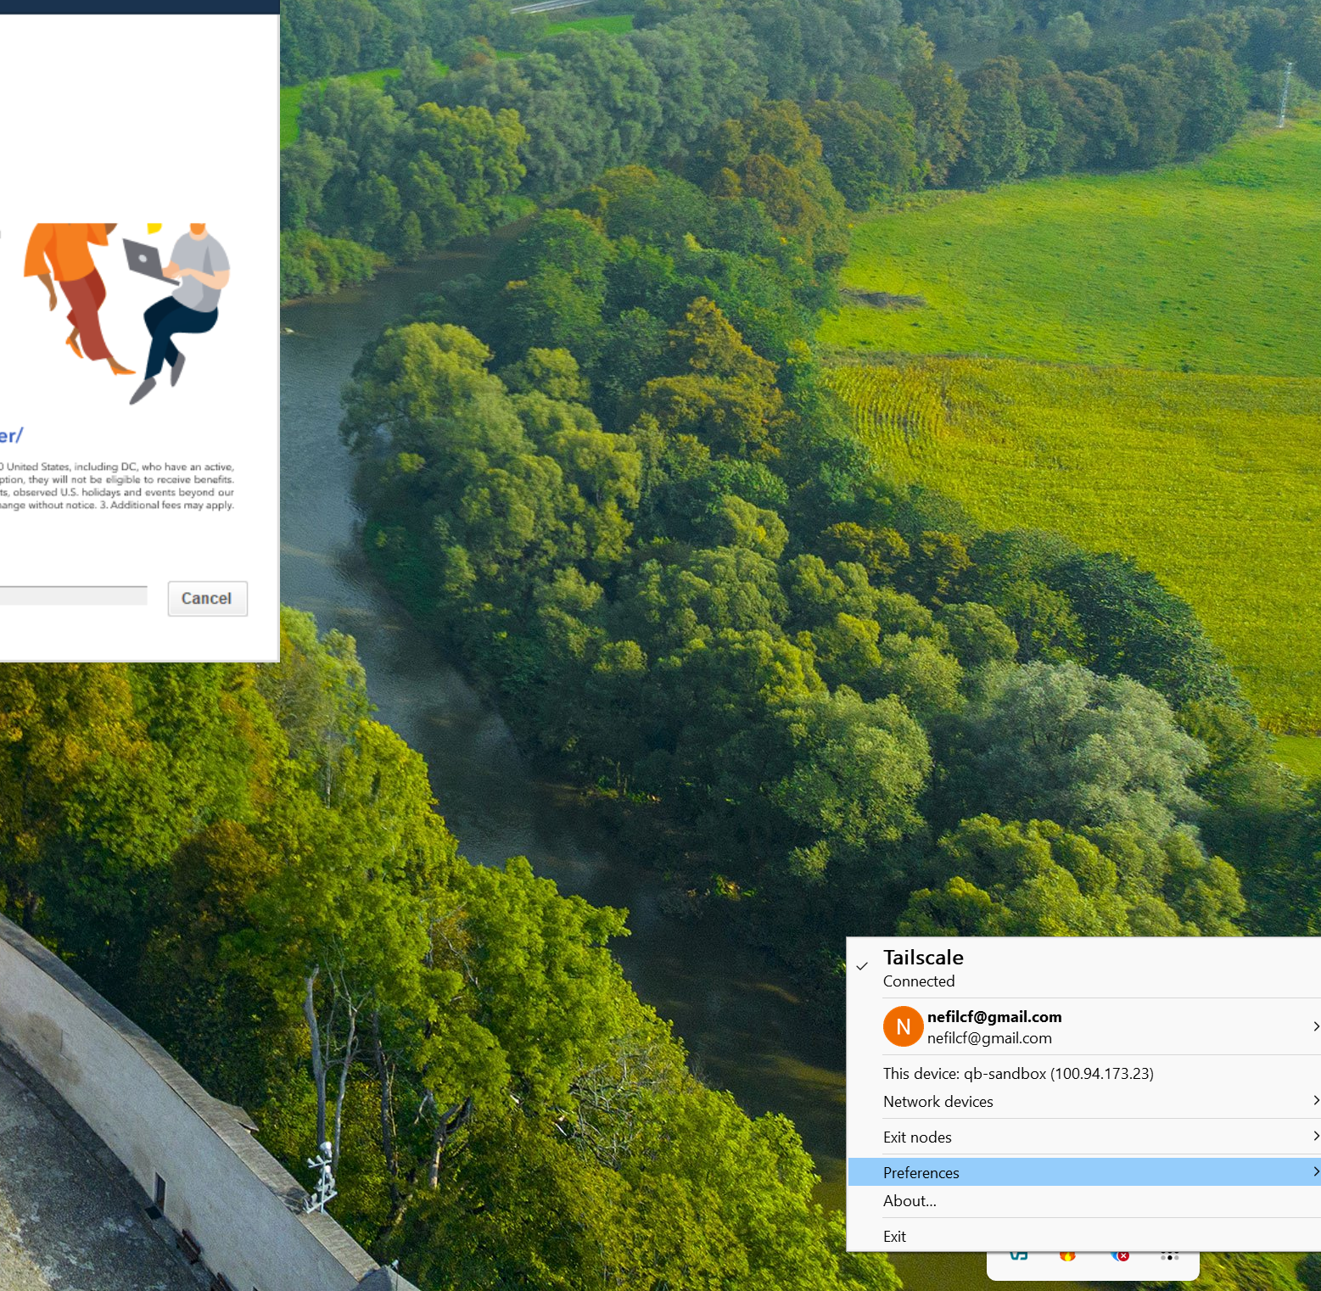
- VPN Invitation (Example): https://login.tailscale.com/uinv/i3eoGdyebi11VwJTaTNs221
- Once the Tailscale client is configured on the vendor's side, they connect via RDP using the Tailnet hostname qb-sandbox or the assigned Tailscale IP — no additional NAT configuration required.

3. Firewall Rules (SimpleWall)
We use SimpleWall, a free open-source firewall application that is stricter and more application-oriented than the native Windows Defender Firewall.
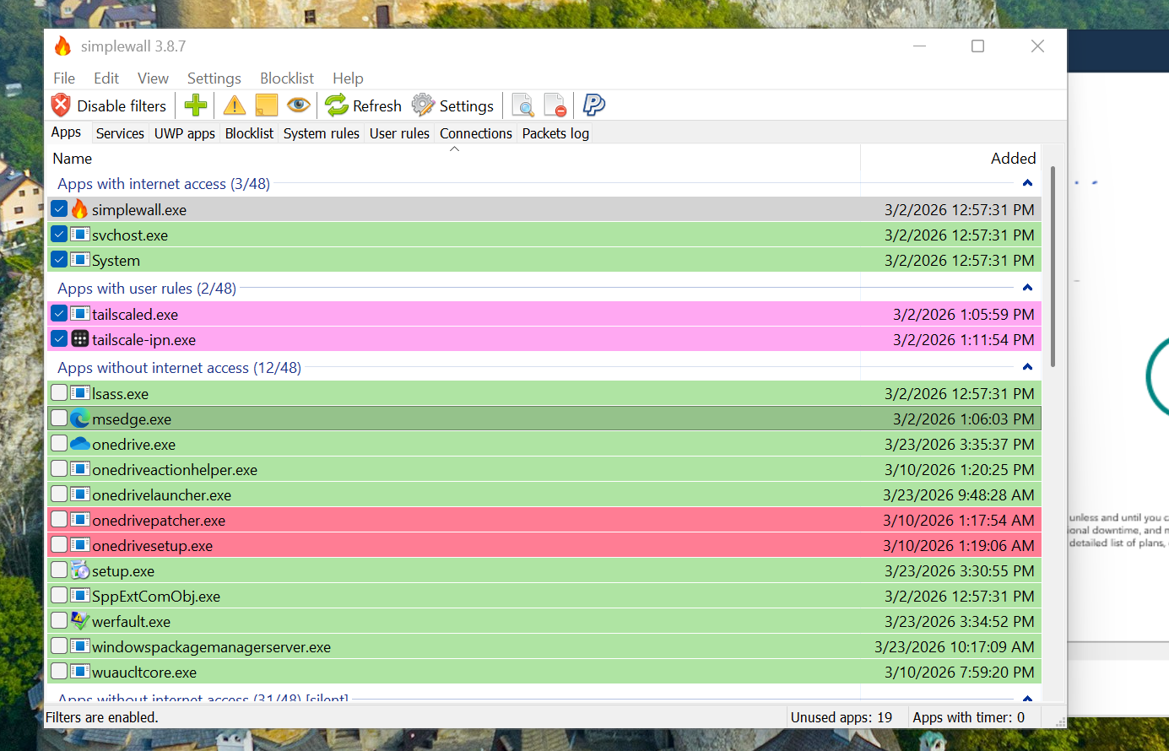
- Essential Allowed Services: Always ensure the green checkbox is enabled for RDP and Tailscale.
  - simplewall.exe
  - svchost.exe
  - System (Required for Windows background tasks and baseline RDP)
  - tailscaled.exe and tailscaled-ipn.exe (Mandatory for the Zero Trust VPN network)
- Web Browsing: If using a web browser is absolutely necessary (admin only), temporarily allow msedge.exe with a simple check.

4. Virtual Machine Snapshot Workflow
Proper snapshot management is critical to maintain the 30-day unlicensed testing environment for QuickBooks.
Snapshot Architecture:
- QB-Isolated-1: The base virtual machine installation.
- QB-Isolated-PreQB: This is a linked clone of QB-Isolated-1. All testing and QuickBooks installations must happen exclusively within this linked clone to preserve the base image.
Snapshot Reset Flow:
When the 30-day QuickBooks trial expires, or a fresh UAT environment is needed, follow this workflow exclusively on QB-Isolated-PreQB:
- Ensure the VM is powered off.
- Select the Pre-QB snapshot within VirtualBox.
- Click Restore (or Revert). This discards the "Current State" and all 30 days of usage.
- Boot the VM. It will instantly return to the exact clean pre-installation state.
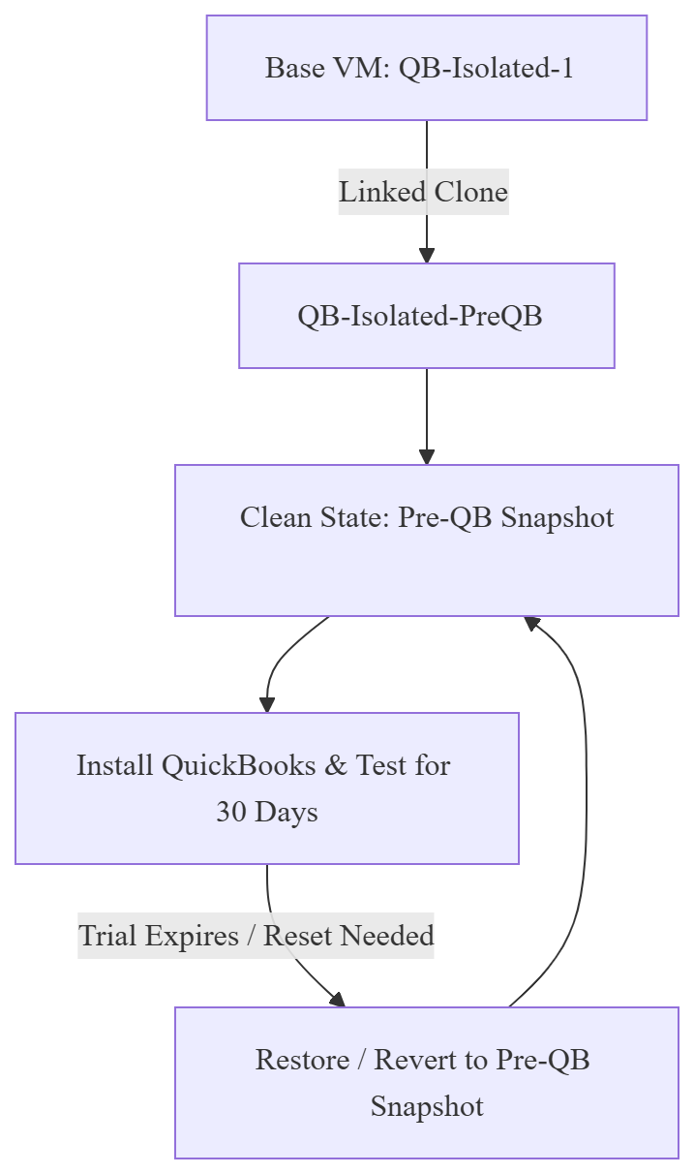
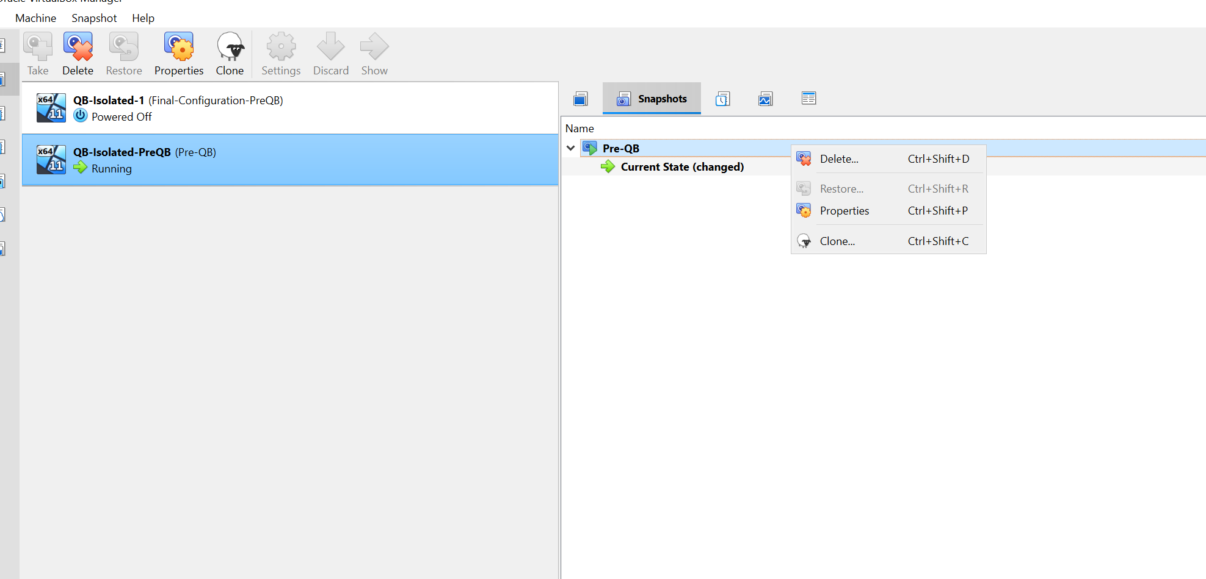

Final Notes & UAT Operations
- Once RDP and Tailscale are configured, connection should be seamless from any approved device within the Casa Familiar IT department.
- For heavy administrative tasks, log directly into VNQB-SERVER.
- Best Practice: Always manage versions by reverting to the mentioned VirtualBox snapshots. Never work or save states over the base installation (QB-Isolated-1) unless applying a forced patch.

